Name
Course
Professor
Institution
Date

ABSORBED BY LIGHT by Gali Lucas and Karoline Hinz (2018)

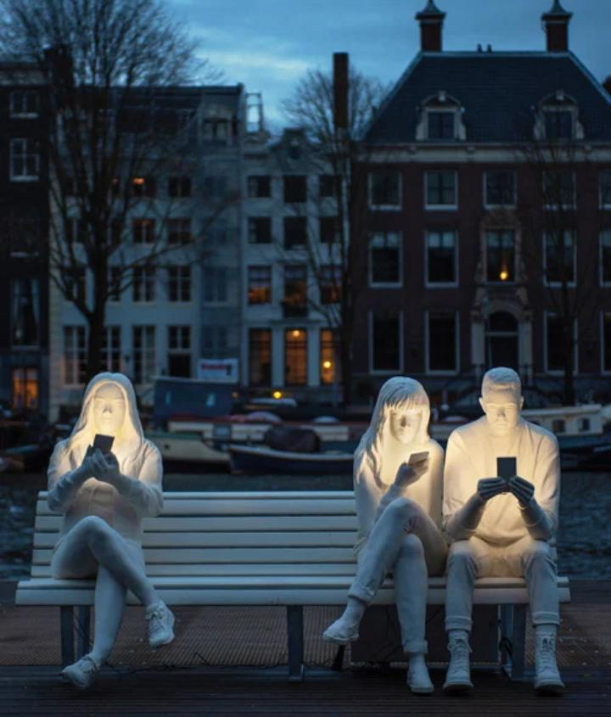
("'Absorbed By Light' Sculpture At Amsterdam Light Festival 2018")
This sculpture is located outside the hermitage in Amsterdam. It was first presented at the Amsterdam light festival in 2018. I first saw this sculpture when my family and I traveled to the western Netherlands. I chose this piece of art because it depicts smartphones and technology in our social lives. It shows how we are obsessed with our phones, thus turning into introverts while in the company of each other. It would be easy to describe the art to someone who hasn’t seen it before. There are three people on a bench, two gentlemen and a lady. The lady and a one-man are seated close to each other on one end of the bench and the other man on the other. They are dressed in white. Their heads are bent, their phones close to their faces with their fingers typing. Light from the phones lights up their faces.
This art reminds me of my peers when we are together. When we meet, we catch up for a few minutes before everyone is on their phones again. We may be hanging out at dinner and having a conversation, but from time to time, someone in the group will be spotted checking their phone. Sometimes the idea of hanging out is meeting up to discuss something we saw on Instagram, Facebook, Twitter, or Pinterest. We use our phones to show each other pictures we saw and end up zoning out of the conversation. We also take a lot of pictures when we are together. 70% of the time I spent on our gadgets. For this reason, I feel like technology is turning us into antisocial people around each other. My first reaction when I came across this piece of art was impressive. I was impressed by how the artists had taken time to give a simple yet detailed description of how we have turned to slaves of our devices. The commitment we have to our phones is more than what we offer each other. The artist shows exactly what goes on in parks, restaurants, workspaces, and even at family functions. The artwork shows emotions of excitement but to our phones, not because we are around each other. Tension can also be felt in art. This is due to the fact that two people are seated so close to each other yet not communicating.
The artists felt triggered and hence the sculpture. Both Gali and Karoline felt compelled to portray how engrossed we are in our smartphones, tablets, and technology as a whole. It is also safe to conclude that the artists felt concerned about the disruptive effect technology has had on everyone’s life. I would say the sculpture is very beautiful. Beauty, however, is subjective, and others may consider it less or not beautiful at all. In contemporary art, beauty is important in attracting viewers. Most people will share beautiful pieces of art compared to unpleasant ones ("8. All The Arts Equal Beauty -- Experiencingthehumanities.Org"). Beauty can also be used to convey messages that are unpleasant. For example, using bright colors that will tempt the viewer to take time and reflect on the piece of art. Other artists, however, chose to use ugly and unpleasant art to pass their messages. Such art may evoke different feelings and cause controversy and will be shared widely.

Works cited
"'Absorbed By Light' Sculpture At Amsterdam Light Festival 2018". Designboom | Architecture
& Design Magazine, 2020, https://www.designboom.com/art/absorbed-by-light-design-bridge-gali-may-lucas-amsterdam-light-festival-12-06-2018/.
"8. All The Arts Equal Beauty -- Experiencingthehumanities.Org". Richard.Jewell.Net, 2020,
http://www.richard.jewell.net/ExperiencingHumanities/8allarts.htm.

